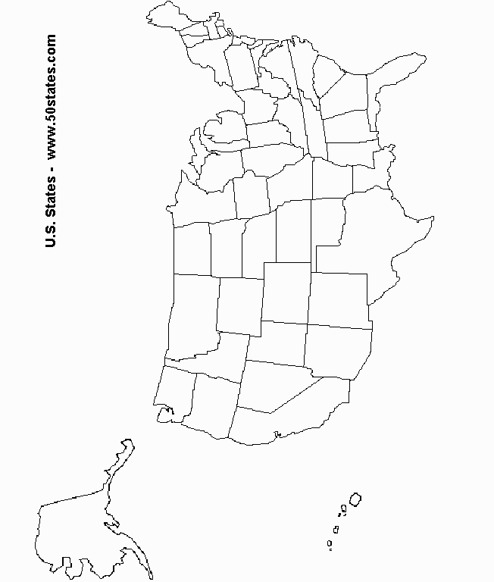

*=Point of original blight infection*

*= American Chestnut population prior to 1910*

*=American Chestnut population after 1950*